**“History is a Greek word which means, literally, just *Investigation.*”**

~Arnold Toynbee

**Course Objectives:**

My primary objective is to foster the *intellectual curiosity* of each student. I hope to teach each student to ask questions, but furthermore, to develop as a *collaborative learner* who approaches problems analytically, and independently seeks out resources to find answers. In addition, I expect each student to become an *effective communicator* of her/his ideas. Through in-depth projects, students are encouraged to *apply the knowledge* learned in the classroom to the outside world, making connections between past and present, school and community, classroom and outside world.

**Behavioral Guidelines:**

This classroom runs on one basic principle, **respect**. Respect means to have a sense of admiration based on achievements, qualities, or abilities. In this classroom your will:

**Respect yourselves.**

**Respect others.**

**Respect learning.**

**Respect the classroom.**

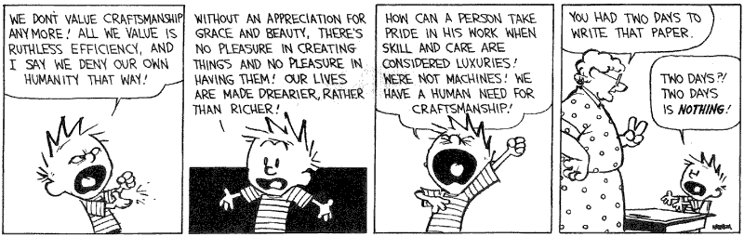

**Grade Scale:**

|  |  |
| --- | --- |
| **Grade** | **Percentage** |
| A | 90-100 |
| B | 80-89.9 |
| C | 70-79.9 |
| D | 60-69.9 |
| F | 0-59.9 |

My grading policy is simple. Every assignment, project, discussion, etc. is entered based on the points it is worth. There are no weighted categories. There are no magic cures. You decide your grade based on how hard you are willing to work. Your grade is comprised of all the points you earn divided by the available points.

**Tardy Policy:**

Arriving on time for class is extremely important. We have a limited amount of time each week and I consider this time sacred. As we move through our projects this time becomes even more valuable because it will determine the amount of work you must complete at home. I expect all students to be in their seats at the start of class ready to learn. A student is considered tardy if these conditions are not met. Just being in the classroom is not good enough.

**“To be early is to be on time. To be on time is to be late. To be late is to be forgotten.” ~Old Football Coach**

**Late Work Policy:**

Assignments are considered late if they are not ready to turn in at the stated deadline. Late assignments are worth ½ credit. For example, if an assignment earns 80 out of 100 points but is turned in late, the student will only receive 40 points (50% of 80 = 40 points). Therefore, late work will never receive higher than a 50 percent. **No late work will be accepted more than two calendar weeks past the due date.** If you ever foresee challenges in meeting deadlines, please communicate with me as extensions may be granted when deemed appropriate.

Remember: If you tell me in advance, it is a reason – if you tell me after, it is an excuse.

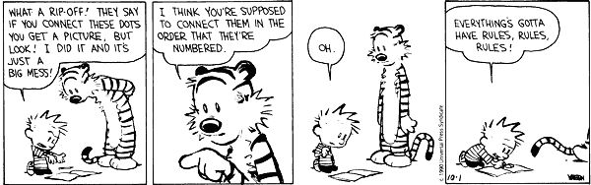

**Tests:**I foresee giving very few tests throughout the course of the year. I believe that the ability to regurgitate information once and then forget it for the rest of your life is a waste of not only your time, but also mine. There may be times when a test is required but they will be very few and far in between.

**Projects:**This class utilizes Project Based Learning or PBL for short. PBL stresses using class time for the acquisition and application of knowledge through collaborative group projects and individual projects. These projects will allow us to produce work that demonstrates our knowledge instead of quantifies it. These projects will also teach us the real-world skills that are required for success in the 21st century. There will be projects for each major unit we cover.

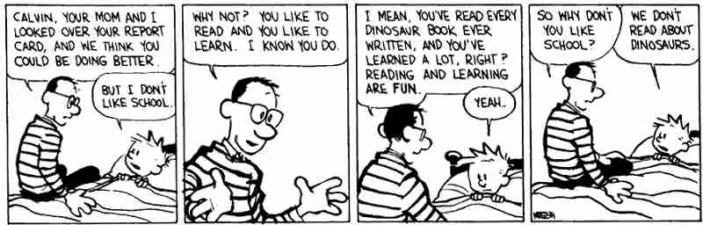

**Plagiarism:**

**Plagiarism is defined as: the practice of taking someone else's work or ideas and passing them off as one's own.** This is not acceptable in any: way, shape, or form in my class. I utilize plagiarism-checking software to check student work. It is very accurate.

**Plagiarism includes: copying answers, cutting and pasting from the Internet, not citing your sources, or attempting to pass someone else’s work off as your own. Plagiarism also includes rewording someone else’s words but keeping their ideas and argument. Just because you changed 2 words in each sentence does not mean it is your work.**

If you plagiarize you will receive a 0 on the assignment, your citizenship grade will be lowered by 1 grade, and your home will be contacted. If you plagiarize a second time you will receive a 0 on the assignment, your home will be contacted, you will receive a referral, and your citizenship grade will be dropped 1 additional grade. Just don’t do it. **When in doubt put quotation marks around it and cite.**

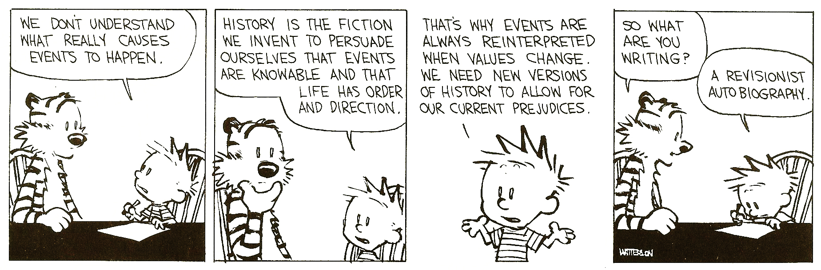

**Citizenship Rubric**

We work together a lot! It is imperative that students demonstrate proper classroom behavior every day. Citizenship grades are determined by classroom behavior. The following descriptions will better illustrate how I evaluate student citizenship.

**Citizenship grade of “A” -** These students demonstrate outstanding behavior every day. They always remain on task without reminders. These students always treat the teacher and other students with respect. They are always polite and listening when the teacher is speaking.

**Citizenship grade of “B” -** These students consistently demonstrate appropriate behavior. These students only require occasional reminders to remain on task. They always treat the teacher and other students with respect. They are generally polite and listen when the teacher is speaking.

**Citizenship grade of “C” -** These students demonstrate average behavior. They may require reminders to remain on task. These students may not listen to the teacher’s instructions. These students may be easily distracted.

**Citizenship grade of “D” -** These students demonstrate below average behavior. They are frequently off task and create a distraction to the learning environment. These students have consistent difficulty with following teacher instructions and require constant monitoring. They tend to be disruptive when the teacher is speaking.

**Citizenship grade of “F” -** These students demonstrate behavior that is unacceptable in the classroom.